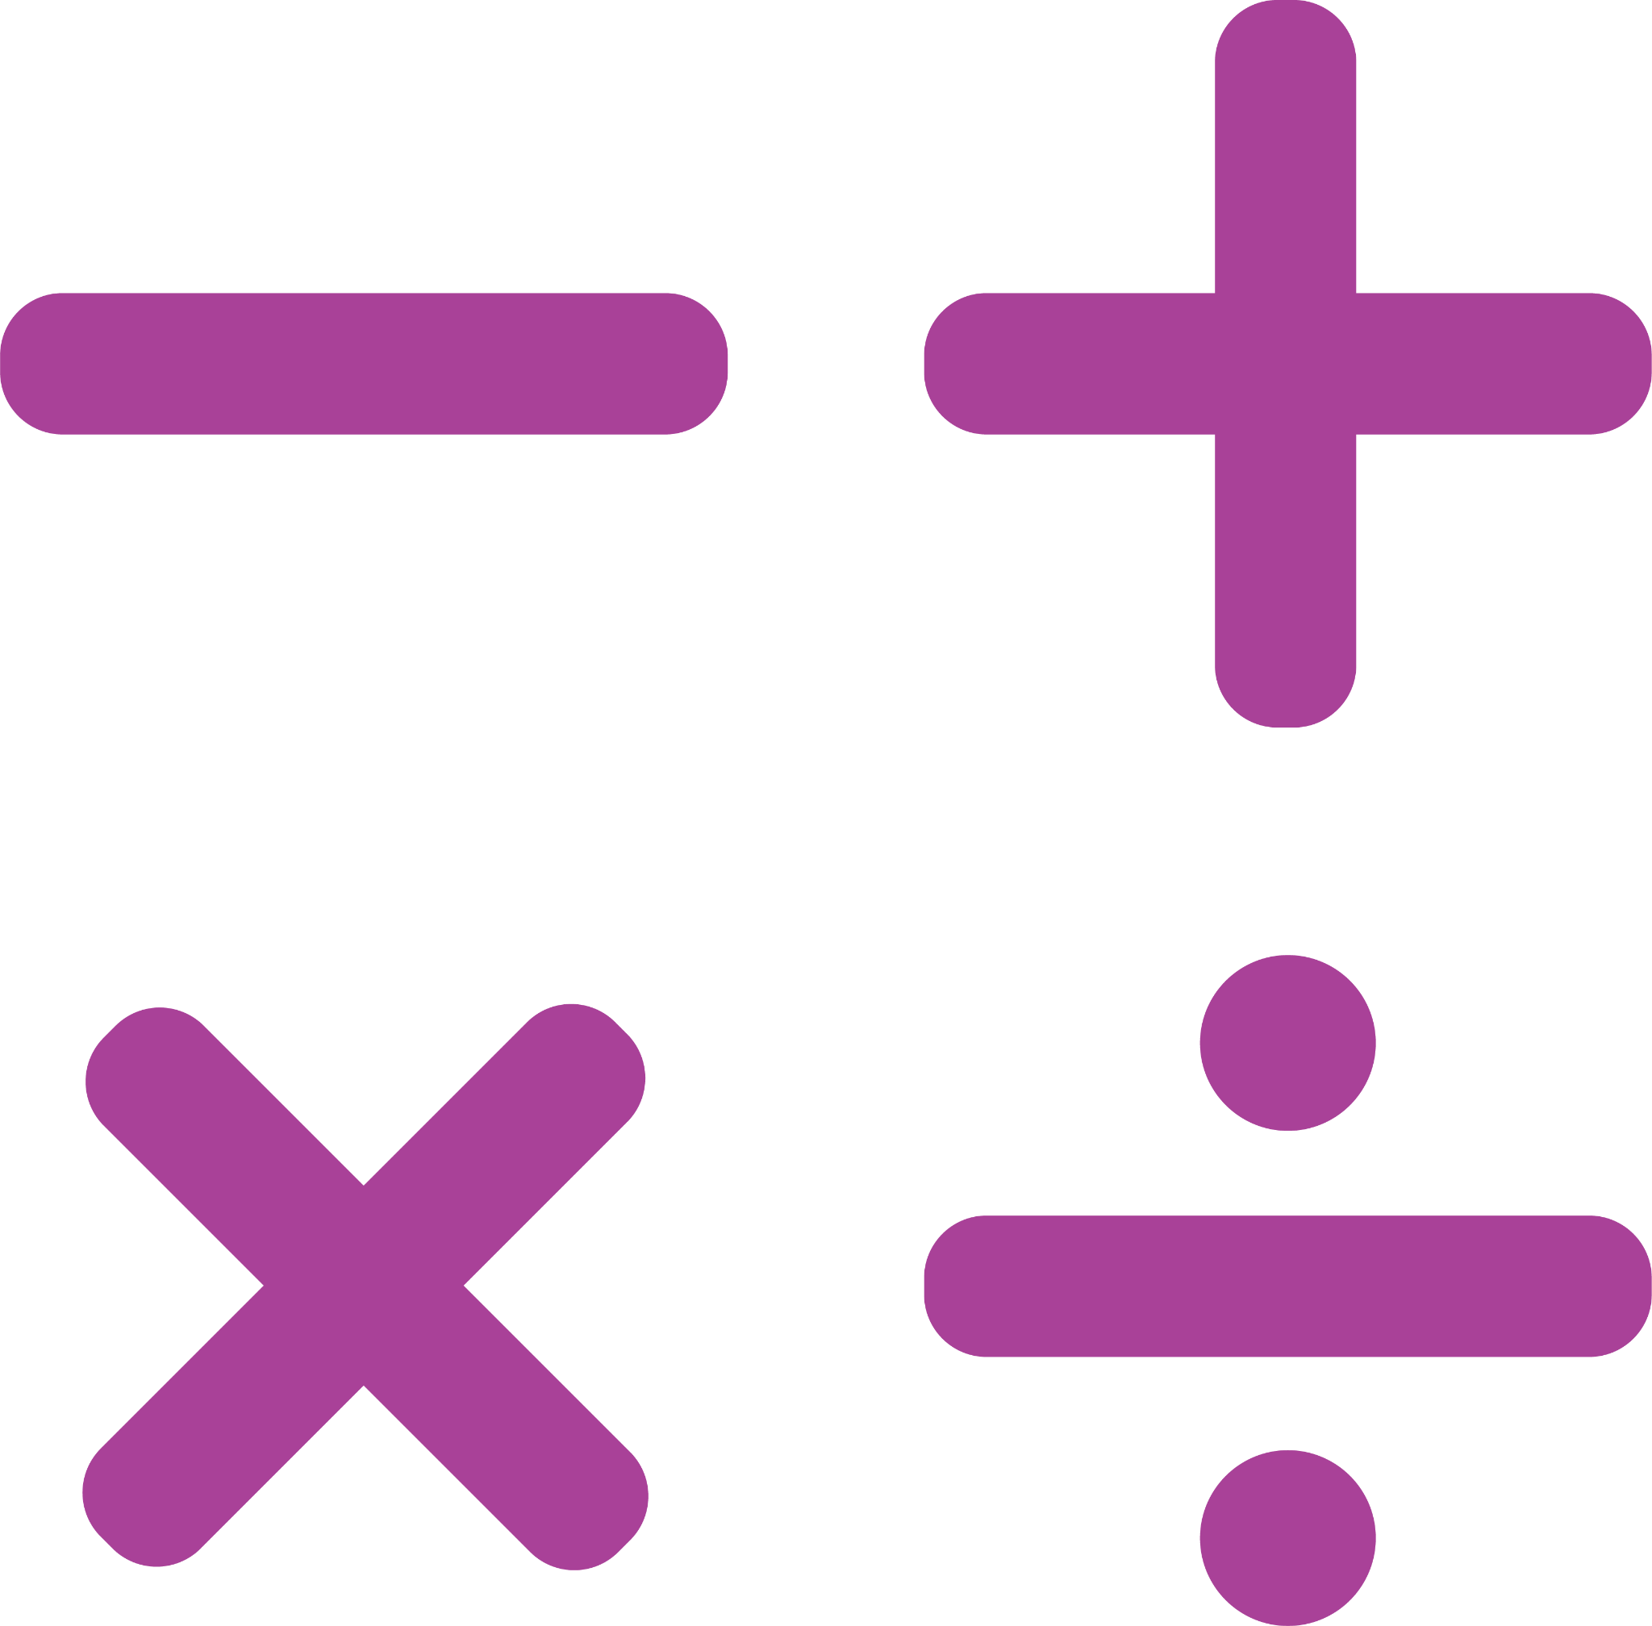
CHECKLIST FOR ERROR ANALYSIS
NAME: |  | DATE:

TOPIC:
Read the problem carefully and analyze the mistakes made when solving it. Consider the nature of the error and the steps taken by the person attempting to solve the problem.

When solving this problem, what are the key elements? (context clues, important details given)

Why do you think they made that mistake?

What are some ways they could have checked their answer?

What is the correct process to solve this problem and record your solution? Could there be multiple solutions, if so, what are they?

