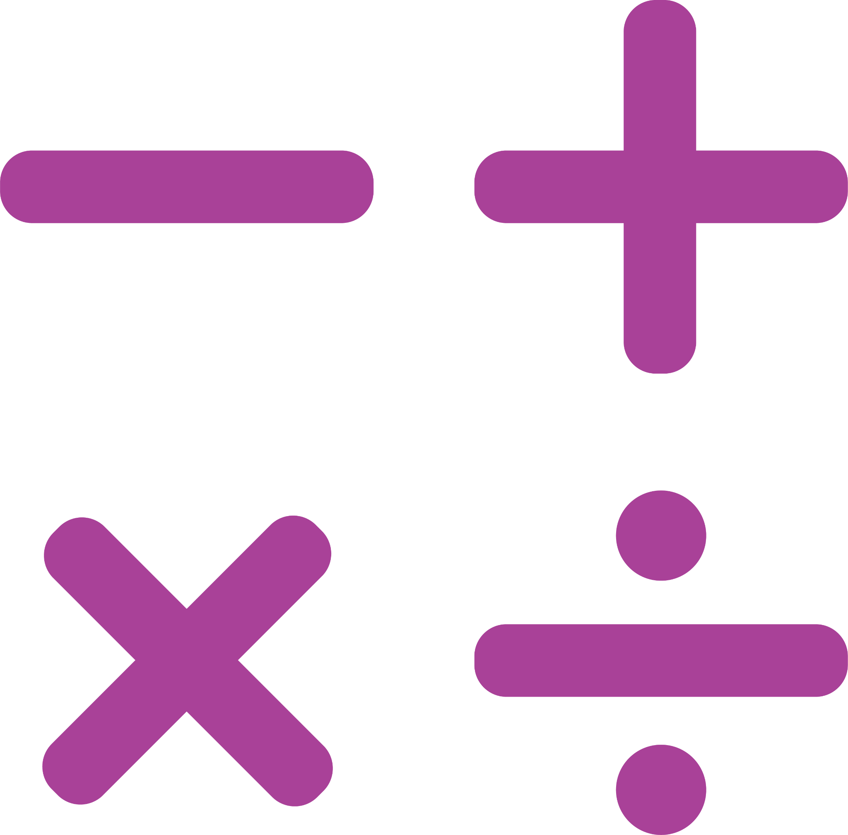
FRAYER MODEL
NAME: |  | DATE:

TOPIC:
Draw a picture representing the geometric shape or concept in the middle circle and then provide the definition, characteristics, real-world applications, and formulas.

Geometric Shape/
Concept
Definition | Characteristics
A clear and concise definition of the geometric shape or concept being studied. | Key attributes or features of the geometric shape or concept such as angles, sides, and measurements.
Examples of the geometric shape or concept in real-world structures or designs. | Formulas related to the geometric shape or concept being studied.
Real-world Applications | Formulas

