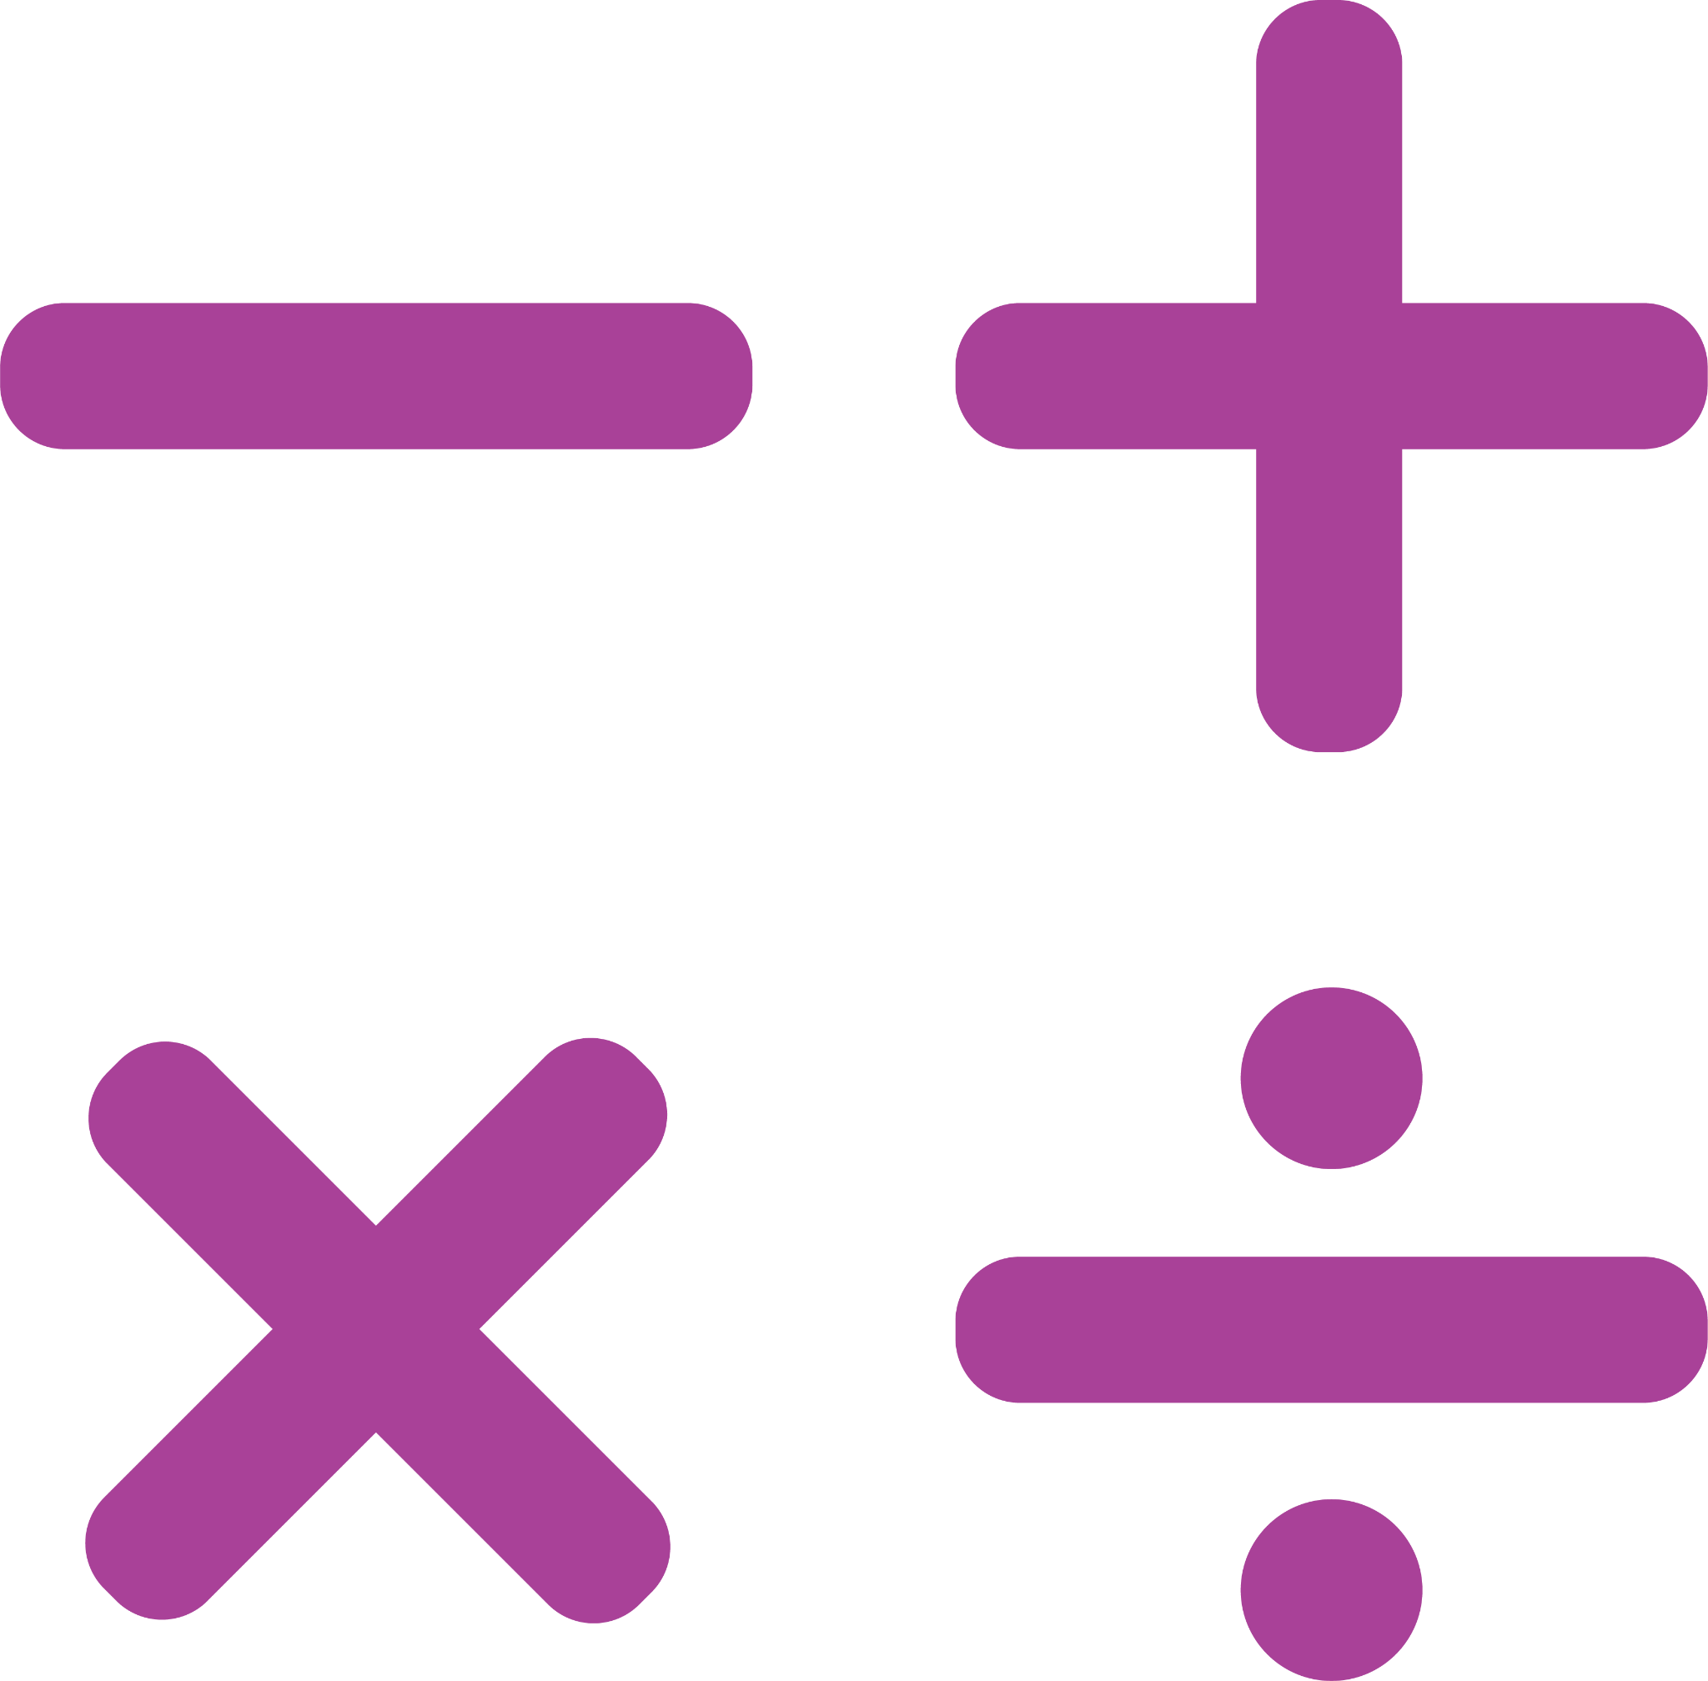
MATH SENTENCE FRAMES
NAME: |  | DATE:

TOPIC:

SENTENCE STARTERS TO EXPLAIN

The strategy I used was _________________________________________________________________________________

I noticed that _________________________________________________________________________________________

I solved the problem by _________________________________________________________________________________

The first thing I did to solve the problem was ________________________________________________________________

I wonder _____________________________________________________________________________________________

I know that ___________________________________________________________________________________________

SENTENCE STARTERS TO AGREE

I agree with _____________________________________ because ______________________________________________

My strategy is like yours because _________________________________________________________________________

That solution makes sense because _______________________________________________________________________

I came up with the same solution by ______________________________________________________________________

SENTENCE STARTERS TO DISAGREE

I disagree with ____________________________________ because ____________________________________________

My strategy is not like yours because ______________________________________________________________________

That solution does not make sense because ________________________________________________________________

I came up with a different because I _______________________________________________________________________

SENTENCE STARTERS TO CLARIFY

Can you explain how ___________________________________________________________________________________

I have a question about _________________________________________________________________________________

Can you explain _________________________________________________________________________________ again?

I still don’t understand _________________________________________________________________________________

SENTENCE STARTERS TO EXTEND

I would like to add onto _________________________________________________________________________________

Another strategy we could use is _________________________________________________________________________

My solution is correct/incorrect because ___________________________________________________________________

I can check my solution by ______________________________________________________________________________

