
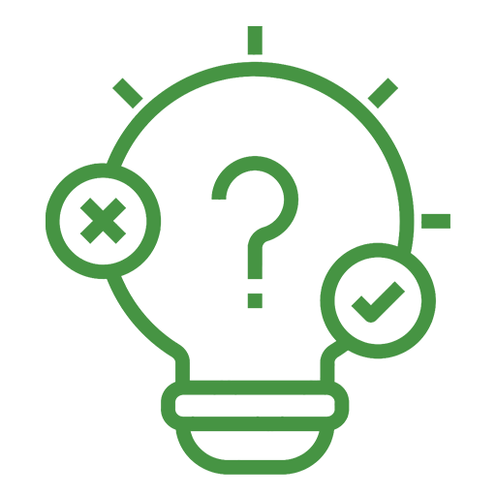  HYPOTHESIZE  STOP when a prediction or theory is made.  Ask: What would I expect based on this information?    EXPERIMENT  STOP when a method is described.  Ask: How is this being tested? What variables are involved? What issues or limitations might there be with the method?    OBSERVE/  DESCRIBE  STOP when results or findings are shared.  Ask: What patterns or trends are emerging? How does it relate to the hypothesis?  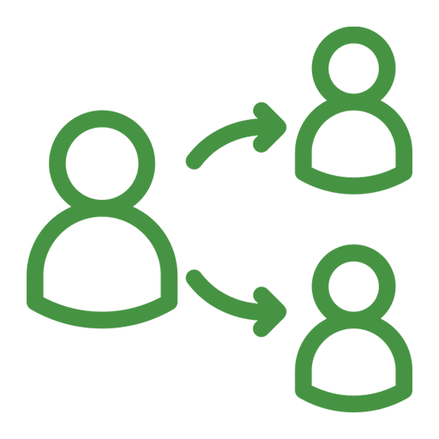  SHARE  STOP when conclusions are drawn.  Ask: How does this contribute to scientific understanding? How would I alter or extend the experiment? | HYPOTHESIZE  STOP when a prediction or theory is made.  Ask: What would I expect based on this information?  EXPERIMENT  STOP when a method is described.  Ask: How is this being tested? What variables are involved? What issues or limitations might there be with the method?  OBSERVE/  DESCRIBE  STOP when results or findings are shared.  Ask: What patterns or trends are emerging? How does it relate to the hypothesis?  SHARE  STOP when conclusions are drawn.  Ask: How does this contribute to scientific understanding? How would I alter or extend the experiment? | HYPOTHESIZE  STOP when a prediction or theory is made.  Ask: What would I expect based on this information?  EXPERIMENT  STOP when a method is described.  Ask: How is this being tested? What variables are involved? What issues or limitations might there be with the method?  OBSERVE/  DESCRIBE  STOP when results or findings are shared.  Ask: What patterns or trends are emerging? How does it relate to the hypothesis?  SHARE  STOP when conclusions are drawn.  Ask: How does this contribute to scientific understanding? How would I alter or extend the experiment? | HYPOTHESIZE  STOP when a prediction or theory is made.  Ask: What would I expect based on this information?  EXPERIMENT  STOP when a method is described.  Ask: How is this being tested? What variables are involved? What issues or limitations might there be with the method?  OBSERVE/  DESCRIBE  STOP when results or findings are shared.  Ask: What patterns or trends are emerging? How does it relate to the hypothesis?  SHARE  STOP when conclusions are drawn.  Ask: How does this contribute to scientific understanding? How would I alter or extend the experiment? | HYPOTHESIZE  STOP when a prediction or theory is made.  Ask: What would I expect based on this information?  EXPERIMENT  STOP when a method is described.  Ask: How is this being tested? What variables are involved? What issues or limitations might there be with the method?  OBSERVE/  DESCRIBE  STOP when results or findings are shared.  Ask: What patterns or trends are emerging? How does it relate to the hypothesis?  SHARE  STOP when conclusions are drawn.  Ask: How does this contribute to scientific understanding? How would I alter or extend the experiment?

