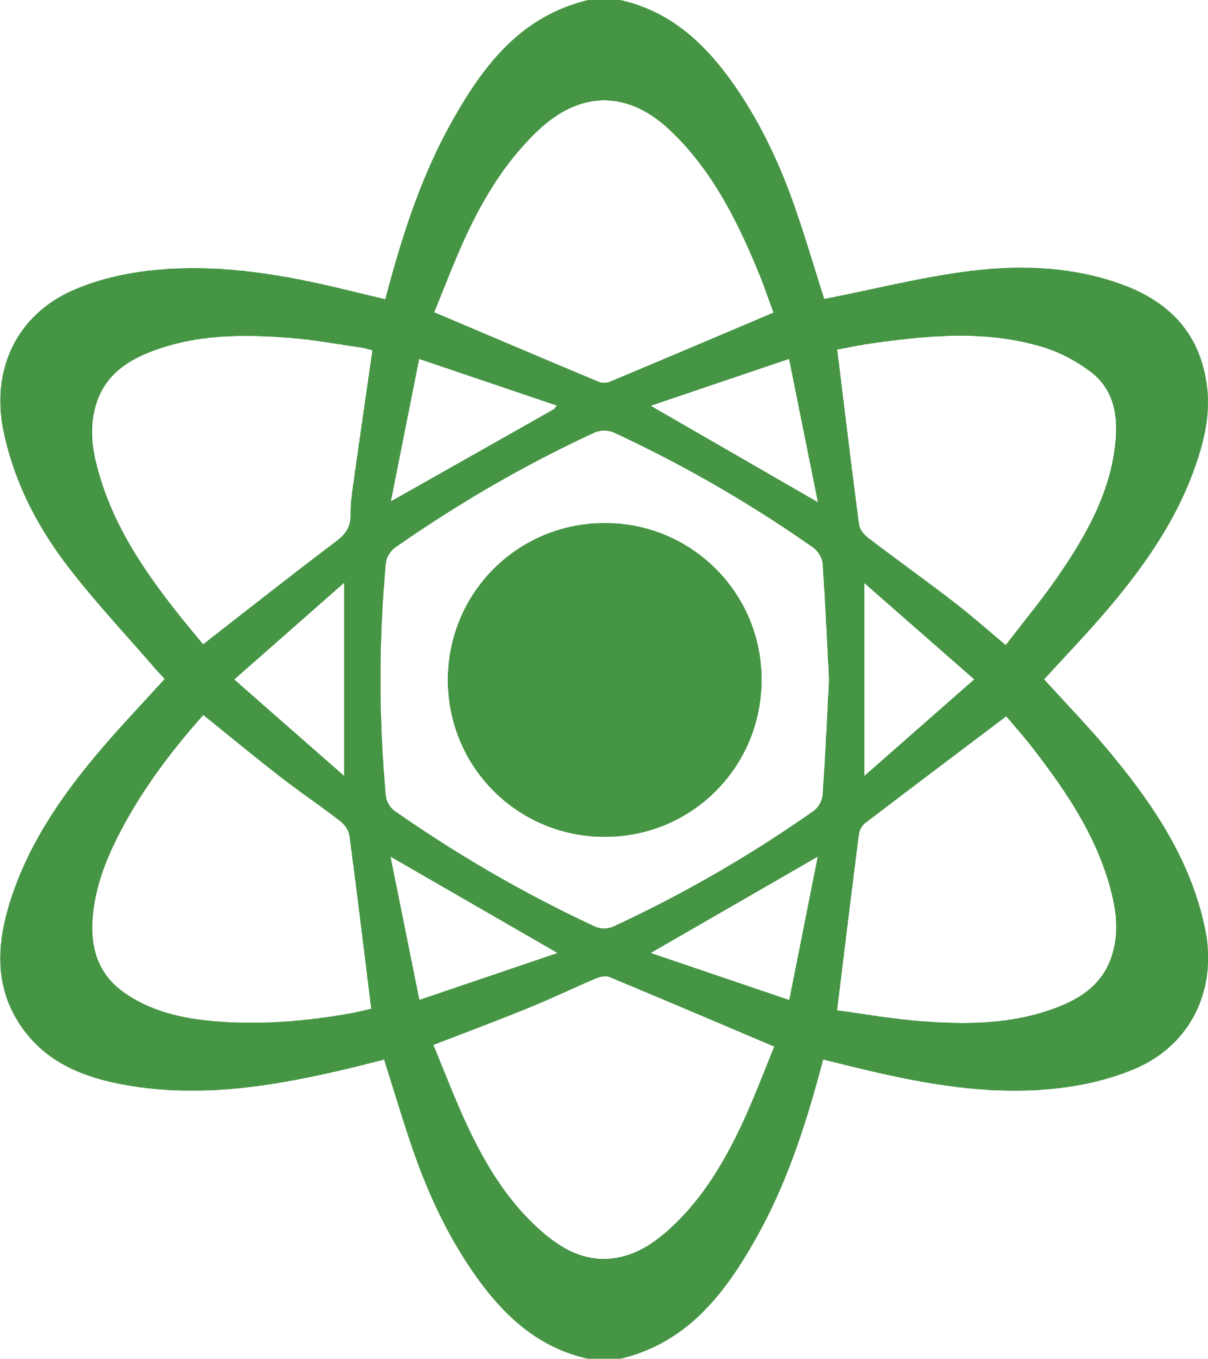
Science  Signposts  When engaging with scientific texts, focus on inquiry and discovery.    QUESTION  STOP when a new concept is introduced.  Ask: What do I need to know more about?    GATHER  INFORMATION  STOP when definitions, data, or explanations appear.  Ask: What facts and observations are important?    RESEARCH/BUILD  KNOWLEDGE  STOP when references or prior studies are cited.  Ask: How does this build on what is already known? What do I need to understand to be able to understand this experiment? | Science  Signposts  When engaging with scientific texts, focus on inquiry and discovery.  QUESTION  STOP when a new concept is introduced.  Ask: What do I need to know more about?  GATHER  INFORMATION  STOP when definitions, data, or explanations appear.  Ask: What facts and observations are important?  RESEARCH/BUILD  KNOWLEDGE  STOP when references or prior studies are cited.  Ask: How does this build on what is already known? What do I need to understand to be able to understand this experiment? | Science  Signposts  When engaging with scientific texts, focus on inquiry and discovery.  QUESTION  STOP when a new concept is introduced.  Ask: What do I need to know more about?  GATHER  INFORMATION  STOP when definitions, data, or explanations appear.  Ask: What facts and observations are important?  RESEARCH/BUILD  KNOWLEDGE  STOP when references or prior studies are cited.  Ask: How does this build on what is already known? What do I need to understand to be able to understand this experiment? | Science  Signposts  When engaging with scientific texts, focus on inquiry and discovery.  QUESTION  STOP when a new concept is introduced.  Ask: What do I need to know more about?  GATHER  INFORMATION  STOP when definitions, data, or explanations appear.  Ask: What facts and observations are important?  RESEARCH/BUILD  KNOWLEDGE  STOP when references or prior studies are cited.  Ask: How does this build on what is already known? What do I need to understand to be able to understand this experiment? | Science  Signposts  When engaging with scientific texts, focus on inquiry and discovery.  QUESTION  STOP when a new concept is introduced.  Ask: What do I need to know more about?  GATHER  INFORMATION  STOP when definitions, data, or explanations appear.  Ask: What facts and observations are important?  RESEARCH/BUILD  KNOWLEDGE  STOP when references or prior studies are cited.  Ask: How does this build on what is already known? What do I need to understand to be able to understand this experiment?

